**CS499 Artifact 2 IT 315 Final Project Submission Stephan**

**Name:** Paul Stephan

**Date: 02-11-2024**

* **Creation:** Generate your student information system (SIS) use case diagram. Refer to textbook pages 121–129.

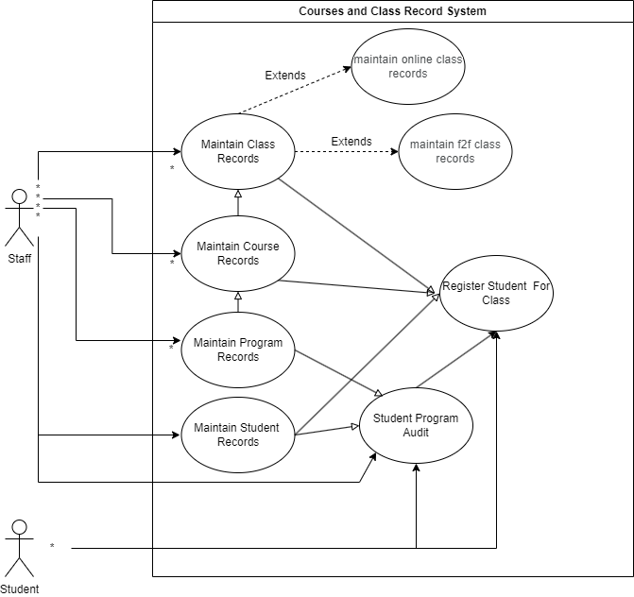



Using the **use case description template** (refer to textbook pages 141–148), provide a description for **each** use case in your use case diagram:

**Use Case 1:**

| Use Case Name:  Maintain Student Records | ID:  1 | Importance Level:  high |
| --- | --- | --- |
| Primary Actor:  Enrolling Staff | Use Case Type:  overview, essential | |
| Stakeholders and Interests:  Enrolling Staff - wants to make sure all students are accounted for and have accurate data  Students - Want to make sure their data is accurate and can enroll in classes | | |
| Brief Description:  Staff use this to ensure there is basic information about all students. | | |
| Trigger:  New students need added or there is a change of information about a current students  Type:  External | | |
| Relationships   * Association:   Student   * Include: * Extend: * Generalization: | | |
| Normal Flow of Events:  1.New student joins the school or current student needs data changed.  2.Contacts staff for change.  3.Gives staff the new information.  4.Staff changes information. | | |
| SubFlows: | | |
| Alternate/Exceptional Flows: | | |

**Use Case 2:**

| Use Case Name:  Maintain Course Records | ID:  2 | Importance Level:  high |
| --- | --- | --- |
| Primary Actor:  Enrolling Staff | Use Case Type:  overview, essential | |
| Stakeholders and Interests:  Enrolling Staff - wants to make sure all courses are available and have accurate data  Students - Want to make sure they have current information on courses being offered. | | |
| Brief Description:  Staff use this to ensure there is current information about courses. | | |
| Trigger:  New course is added or old course has information change  Type:  External | | |
| Relationships   * Association:   Student   * Include: * Extend: * Generalization: | | |
| Normal Flow of Events:  1.New course or old course needs change.  2.Staff gets new information.  3.Staff changes information. | | |
| SubFlows: | | |
| Alternate/Exceptional Flows: | | |

**Use Case 3:**

| Use Case Name:  Maintain Class Records | ID:  3 | Importance Level:  high |
| --- | --- | --- |
| Primary Actor:  Enrolling Staff | Use Case Type:  overview, essential | |
| Stakeholders and Interests:  Enrolling Staff - wants to make sure all classes are available and have accurate data  Students - Want to make sure they have current information on classes being offered. | | |
| Brief Description:  Staff use this to ensure there is current information about classes. Requires valid course information to be created | | |
| Trigger:  New class is added or update old class to current term  Type:  External | | |
| Relationships   * Association:   Course Records   * Include: * Extend:   Online Attribute  Face-to-Face Attributes   * Generalization: | | |
| Normal Flow of Events:  1.New class or old class needs change to current term.  2.Staff gets class information.  If online go to online subflow  If in person go to face-to-face subflow  3.Staff gets associated course information.  4.Staff changes information. | | |
| SubFlows:  Online subflow:  Add online attributes  Face-to-Face subflow:  Add Face-to-Face attributes | | |
| Alternate/Exceptional Flows: | | |

**Use Case 4:**

| Use Case Name:  Register Student for Class | ID:  4 | Importance Level:  high |
| --- | --- | --- |
| Primary Actor:  Enrolling Staff/Student | Use Case Type:  overview, essential | |
| Stakeholders and Interests:  Enrolling Staff - wants to make sure all Students are enrolled in the classes they want  Students - Want to make sure they have current information on classes being offered. | | |
| Brief Description:  Staff use this to ensure there is current information about classes. Requires valid course information to be created | | |
| Trigger:  New class is added or update old class to current term  Type:  External | | |
| Relationships   * Association:   Course Record, Class Record, Student Records   * Include: * Extend: * Generalization: | | |
| Normal Flow of Events:  1.Student wants to enroll in class  2.Get course, class, and student information  3.Check requirements for enrolling in class.  If fails go to alternative flow 1  4.Add student to class.  5.create confirmation message | | |
| SubFlows: | | |
| Alternate/Exceptional Flows:  Alt-1 If fails output message with reason for failure. | | |

**Use Case 5:**

| Use Case Name:  Maintain Program Record | ID:  5 | Importance Level:  high |
| --- | --- | --- |
| Primary Actor:  Enrolling Staff | Use Case Type:  overview, essential | |
| Stakeholders and Interests:  Enrolling Staff - wants to make sure all programs are updated with course requirements  Students - Wants to know what each course needs for graduation | | |
| Brief Description:  Staff use this to maintain the requirements for each degree program | | |
| Trigger:  New program is added or update old program to current requirements  Type:  External | | |
| Relationships   * Association:   Course Record, Student program Audit   * Include: * Extend: * Generalization: | | |
| Normal Flow of Events:  1.New program or old program needs change.  2.Staff gets new information.  3.Staff changes information. | | |
| SubFlows: | | |
| Alternate/Exceptional Flows: | | |

**Use Case 6:**

| Use Case Name:  Student Program Audit | ID:  6 | Importance Level:  medium |
| --- | --- | --- |
| Primary Actor:  Student, Staff | Use Case Type:  overview | |
| Stakeholders and Interests:  Enrolling Staff - checks to make sure they know what class is needed for students program  Students - checks to make sure they know what class is needed for students program | | |
| Brief Description:  Compares course requirement to students information and current completed course to determine what else is needed. | | |
| Trigger:  Student completes a course  Program requirements change  Type:  External | | |
| Relationships   * Association:   Program Record, Student Records   * Include: * Extend: * Generalization: | | |
| Normal Flow of Events:  1.Student completes course  2. Audit updates for new needs  3. Show courses left for program completion | | |
| SubFlows: | | |
| Alternate/Exceptional Flows: | | |

* **Testing:** Verify and validate your use case diagram and use case descriptions against the SIS requirements definition.

This diagram is valid and verified by checking the diagram to the description. All of the elements in the description are included in the diagram. All of the objects in the diagram are mentioned in the description. The sequence is the same in the diagram as it is in the use of the software. Lastly there is only one description per use case in the diagram.

* **Approach Explanation:** Explain your approach to the problem, the decisions you made to arrive at your solution, and how you completed it.

I used the use cases in the system requirements to make the use-case diagram. From there I put each use case into a description and walked through the steps each one should go through for the software to work as intended.

* **Self-Reflection:** Reflect on this experience and the lessons you learned from it.

I found it challenging to look at everything that needs to be included and ensure every aspect is included in the descriptions. Sometimes I felt like I was including too much or not enough but I am happy with where I settled because it describes the function of the software and how the different use cases function. The difference from this one and the original submission is a few updates to the use-case diagram. Mainly changing the names to the correct use cases.